BÀI THỰC HÀNH LAB1
Họ và tên: Đặng Đình An
Lớp 11_THMT
II. Luyện tập
AndroidManifest.xml
<?xml version="1.0" encoding="utf-8"?>
<manifest xmlns:android="http://schemas.android.com/apk/res/android"
xmlns:tools="http://schemas.android.com/tools">
<uses-permission android:name="android.permission.CAMERA"/>
<uses-feature android:name="android.hardware.camera" android:required="false" />
<uses-permission android:name="android.permission.CALL_PHONE"/>
<uses-feature android:name="android.hardware.telephony" android:required="false"/>
<uses-permission android:name="android.permission.SEND_SMS"/>
<application
android:allowBackup="true"
android:dataExtractionRules="@xml/data_extraction_rules"
android:fullBackupContent="@xml/backup_rules"
android:icon="@mipmap/ic_launcher"
android:label="@string/app_name"
android:roundIcon="@mipmap/ic_launcher_round"
android:supportsRtl="true"
android:theme="@style/Theme.FirstProgram">
<activity android:name=".CalculatorActivity" />
<activity android:name=".XacSuatActivity" />
<activity android:name=".CallSmsActivity" />
<activity
android:name=".MainActivity"
android:exported="true">
<intent-filter>
<action android:name="android.intent.action.MAIN" />
<category android:name="android.intent.category.LAUNCHER" />
</intent-filter>
</activity>
</application>
</manifest>

MainActivity.java
package com.example.firstprogram;
import androidx.activity.result.ActivityResultLauncher;
import androidx.activity.result.contract.ActivityResultContracts;
import androidx.appcompat.app.AppCompatActivity;
import androidx.core.app.ActivityCompat;
import androidx.core.content.ContextCompat;
import android.Manifest;
import android.content.Intent;
import android.content.pm.PackageManager;
import android.graphics.Bitmap;
import android.os.Bundle;
import android.provider.MediaStore;
import android.widget.*;
public class MainActivity extends AppCompatActivity {
Button btnCamera, btnOpenCalculator, btnOpenXacSuat, btnOpenCallSms;
ImageView imgPhoto;
ActivityResultLauncher<Intent> cameraLauncher;
@Override
protected void onCreate(Bundle savedInstanceState) {
super.onCreate(savedInstanceState);
setContentView(R.layout.activity_main);
btnCamera = findViewById(R.id.btnCamera);
btnOpenCalculator = findViewById(R.id.btnOpenCalculator);
btnOpenXacSuat = findViewById(R.id.btnOpenXacSuat);
btnOpenCallSms = findViewById(R.id.btnOpenCallSms);
imgPhoto = findViewById(R.id.imgPhoto);
setupCameraLauncher();
requestCameraPermission();
// ✅ Bấm mở camera
btnCamera.setOnClickListener(v -> {
Intent intent = new Intent(MediaStore.ACTION_IMAGE_CAPTURE);
cameraLauncher.launch(intent); // 🚀 ép mở luôn
});
// Các nút khác
btnOpenCalculator.setOnClickListener(v -> {
startActivity(new Intent(MainActivity.this, CalculatorActivity.class));
});
btnOpenXacSuat.setOnClickListener(v -> {
startActivity(new Intent(MainActivity.this, XacSuatActivity.class));
});
btnOpenCallSms.setOnClickListener(v -> {
startActivity(new Intent(MainActivity.this, CallSmsActivity.class));
});
}
private void requestCameraPermission() {
if (ContextCompat.checkSelfPermission(this, Manifest.permission.CAMERA)
!= PackageManager.PERMISSION_GRANTED) {
ActivityCompat.requestPermissions(this,
new String[]{Manifest.permission.CAMERA}, 100);
}
}
private void setupCameraLauncher() {
cameraLauncher = registerForActivityResult(
new ActivityResultContracts.StartActivityForResult(),
result -> {
if (result.getResultCode() == RESULT_OK && result.getData() != null) {
Bundle extras = result.getData().getExtras();
Bitmap imageBitmap = (Bitmap) extras.get("data");
imgPhoto.setImageBitmap(imageBitmap);
}
}
);
}
}
activity_main.xml
<?xml version="1.0" encoding="utf-8"?>
<LinearLayout xmlns:android="http://schemas.android.com/apk/res/android"
xmlns:tools="http://schemas.android.com/tools"
android:layout_width="match_parent"
android:layout_height="match_parent"
android:orientation="vertical"
android:padding="20dp"
android:gravity="center"
android:background="#FAF5FF"
tools:context=".MainActivity">
<TextView
android:layout_width="wrap_content"
android:layout_height="wrap_content"
android:text="MỞ CAMERA"
android:textSize="22sp"
android:textStyle="bold"
android:textColor="#6A1B9A"
android:layout_marginBottom="24dp" />
<ImageView
android:id="@+id/imgPhoto"
android:layout_width="250dp"
android:layout_height="250dp"
android:layout_gravity="center"
android:src="@drawable/photo1"
android:scaleType="fitCenter"
android:adjustViewBounds="true" />
<Button
android:id="@+id/btnCamera"
android:layout_width="match_parent"
android:layout_height="wrap_content"
android:text="Mở Camera"
android:backgroundTint="#7E57C2"
android:textColor="#FFFFFF"
android:padding="12dp"
android:textSize="18sp"
android:layout_marginBottom="30dp" />
<!-- Nút mở máy tính -->
<Button
android:id="@+id/btnOpenCalculator"
android:layout_width="match_parent"
android:layout_height="wrap_content"
android:text="Mở Máy tính"
android:backgroundTint="#5E35B1"
android:textColor="#FFFFFF"
android:layout_marginBottom="20dp" />
<Button
android:id="@+id/btnOpenXacSuat"
android:layout_width="match_parent"
android:layout_height="wrap_content"
android:text="Tung Xúc Xắc 🎲"
android:backgroundTint="#9575CD"
android:textColor="#FFFFFF"
android:textSize="18sp"
android:padding="10dp" />
<!-- Nút mở Gọi điện | Nhắn tin -->
<Button
android:id="@+id/btnOpenCallSms"
android:layout_width="match_parent"
android:layout_height="wrap_content"
android:text="Gọi điện | Nhắn tin 📞✉️"
android:backgroundTint="#8E24AA"
android:textColor="#FFFFFF"
android:textSize="18sp"
android:padding="10dp"
android:layout_marginTop="10dp" />
</LinearLayout>

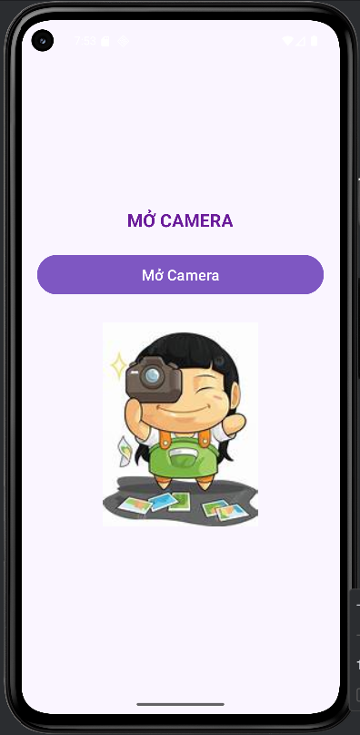
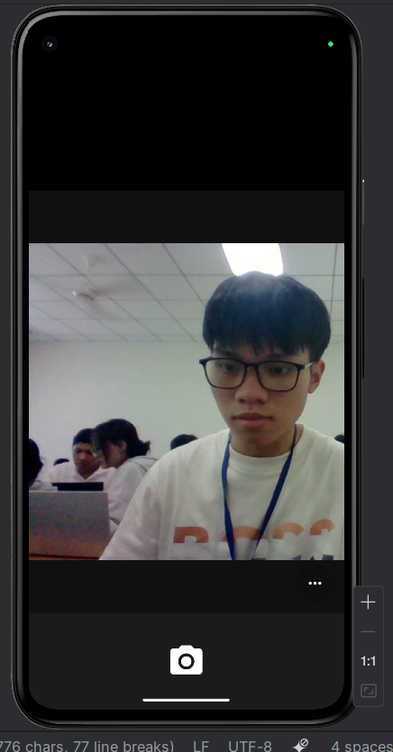
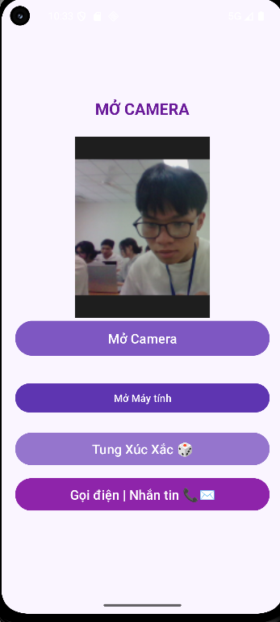

III. Bài tập
Bài tập 1
activity_calculator.xml
<?xml version="1.0" encoding="utf-8"?>
<LinearLayout xmlns:android="http://schemas.android.com/apk/res/android"
xmlns:tools="http://schemas.android.com/tools"
android:layout_width="match_parent"
android:layout_height="match_parent"
android:orientation="vertical"
android:padding="20dp"
tools:context=".CalculatorActivity">
<EditText
android:id="@+id/txtX"
android:layout_width="match_parent"
android:layout_height="wrap_content"
android:hint="Nhập X"
android:inputType="numberDecimal"
android:layout_marginBottom="12dp" />
<EditText
android:id="@+id/txtY"
android:layout_width="match_parent"
android:layout_height="wrap_content"
android:hint="Nhập Y"
android:inputType="numberDecimal"
android:layout_marginBottom="12dp" />
<TextView
android:id="@+id/txtKQ"
android:layout_width="match_parent"
android:layout_height="wrap_content"
android:text="Kết quả:"
android:textSize="20sp"
android:textStyle="bold"
android:layout_marginBottom="20dp" />
<LinearLayout
android:layout_width="match_parent"
android:layout_height="wrap_content"
android:orientation="horizontal"
android:weightSum="5"
android:gravity="center">
<Button
android:id="@+id/btnPlus"
android:layout_width="0dp"
android:layout_height="wrap_content"
android:layout_weight="1"
android:text="+" />
<Button
android:id="@+id/btnMinus"
android:layout_width="0dp"
android:layout_height="wrap_content"
android:layout_weight="1"
android:text="-" />
<Button
android:id="@+id/btnMul"
android:layout_width="0dp"
android:layout_height="wrap_content"
android:layout_weight="1"
android:text="*" />
<Button
android:id="@+id/btnDiv"
android:layout_width="0dp"
android:layout_height="wrap_content"
android:layout_weight="1"
android:text="/" />
<Button
android:id="@+id/btnMod"
android:layout_width="0dp"
android:layout_height="wrap_content"
android:layout_weight="1"
android:text="%" />
</LinearLayout>
</LinearLayout>

CalculatorActivity.java
package com.example.firstprogram;
import androidx.appcompat.app.AppCompatActivity;
import android.os.Bundle;
import android.widget.Button;
import android.widget.EditText;
import android.widget.TextView;
public class CalculatorActivity extends AppCompatActivity {
EditText txtX, txtY;
TextView txtKQ;
Button btnPlus, btnMinus, btnMul, btnDiv, btnMod;
@Override
protected void onCreate(Bundle savedInstanceState) {
super.onCreate(savedInstanceState);
setContentView(R.layout.activity_calculator);
// Ánh xạ view
txtX = findViewById(R.id.txtX);
txtY = findViewById(R.id.txtY);
txtKQ = findViewById(R.id.txtKQ);
btnPlus = findViewById(R.id.btnPlus);
btnMinus = findViewById(R.id.btnMinus);
btnMul = findViewById(R.id.btnMul);
btnDiv = findViewById(R.id.btnDiv);
btnMod = findViewById(R.id.btnMod);
// Gắn sự kiện click cho nút
btnPlus.setOnClickListener(v -> tinhToan("+"));
btnMinus.setOnClickListener(v -> tinhToan("-"));
btnMul.setOnClickListener(v -> tinhToan("*"));
btnDiv.setOnClickListener(v -> tinhToan("/"));
btnMod.setOnClickListener(v -> tinhToan("%"));
}
private void tinhToan(String phepToan) {
double x, y, kq = 0;
try {
x = Double.parseDouble(txtX.getText().toString());
y = Double.parseDouble(txtY.getText().toString());
} catch (Exception e) {
txtKQ.setText("⚠️ Vui lòng nhập số hợp lệ!");
return;
}
switch (phepToan) {
case "+":
kq = x + y;
break;
case "-":
kq = x - y;
break;
case "*":
kq = x * y;
break;
case "/":
if (y == 0) {
txtKQ.setText("⚠️ Không chia được cho 0!");
return;
}
kq = x / y;
break;
case "%":
if (y == 0) {
txtKQ.setText("⚠️ Không chia được cho 0!");
return;
}
kq = x % y;
break;
}
txtKQ.setText("Kết quả: " + kq);
}
}

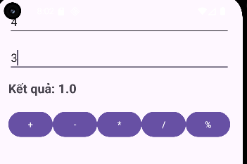

Bài tập 2:
XacSuatActivity.java
package com.example.firstprogram;
import android.os.Bundle;
import android.os.Handler;
import android.view.animation.Animation;
import android.view.animation.AnimationUtils;
import android.widget.Button;
import android.widget.ImageView;
import android.widget.TextView;
import androidx.appcompat.app.AppCompatActivity;
import java.util.Random;
public class XacSuatActivity extends AppCompatActivity {
TextView txtNumber;
ImageView imgDice;
Button btnRandom;
Random random = new Random();
int[] diceFaces = {
R.drawable.dice_1,
R.drawable.dice_2,
R.drawable.dice_3,
R.drawable.dice_4,
R.drawable.dice_5,
R.drawable.dice_6
};
@Override
protected void onCreate(Bundle savedInstanceState) {
super.onCreate(savedInstanceState);
setContentView(R.layout.activity_xac_suat);
txtNumber = findViewById(R.id.txtNumber);
imgDice = findViewById(R.id.imgdice);
btnRandom = findViewById(R.id.btnRandom);
btnRandom.setOnClickListener(v -> tungXucXac());
}
private void tungXucXac() {
// 🔁 Tải animation xoay xúc xắc
Animation shake = AnimationUtils.loadAnimation(this, R.anim.shake_dice);
imgDice.startAnimation(shake);
// 🔄 Hiển thị xúc xắc ngẫu nhiên liên tục trong 3 giây
Handler handler = new Handler();
final int duration = 3000; // 3 giây
final int interval = 100; // đổi mặt mỗi 0.1 giây
final long startTime = System.currentTimeMillis();
Runnable updateDice = new Runnable() {
@Override
public void run() {
if (System.currentTimeMillis() - startTime < duration) {
int randomFace = random.nextInt(6);
imgDice.setImageResource(diceFaces[randomFace]);
handler.postDelayed(this, interval);
} else {
// Dừng animation và hiển thị kết quả cuối
imgDice.clearAnimation();
int so = random.nextInt(6) + 1;
txtNumber.setText(String.valueOf(so));
imgDice.setImageResource(diceFaces[so - 1]);
}
}
};
handler.post(updateDice);
}
}
activity_xac_suat.xml
<?xml version="1.0" encoding="utf-8"?>
<LinearLayout xmlns:android="http://schemas.android.com/apk/res/android"
xmlns:tools="http://schemas.android.com/tools"
android:layout_width="match_parent"
android:layout_height="match_parent"
android:orientation="vertical"
android:gravity="center"
android:padding="20dp"
android:background="#FAF5FF"
tools:context=".XacSuatActivity">
<!-- Text hiển thị số ngẫu nhiên -->
<TextView
android:id="@+id/txtNumber"
android:layout_width="wrap_content"
android:layout_height="wrap_content"
android:text="00"
android:textSize="60sp"
android:textColor="#D50000"
android:textStyle="bold"
android:layout_marginBottom="20dp" />
<!-- Hình xúc xắc -->
<ImageView
android:id="@+id/imgdice"
android:layout_width="200dp"
android:layout_height="200dp"
android:src="@drawable/dice_1"
android:layout_marginBottom="30dp"
android:scaleType="fitCenter" />
<!-- Nút random -->
<Button
android:id="@+id/btnRandom"
android:layout_width="match_parent"
android:layout_height="wrap_content"
android:text="TUNG XÚC XẮC 🎲"
android:textSize="18sp"
android:textColor="#FFFFFF"
android:backgroundTint="#7E57C2"
android:padding="10dp" />
</LinearLayout>

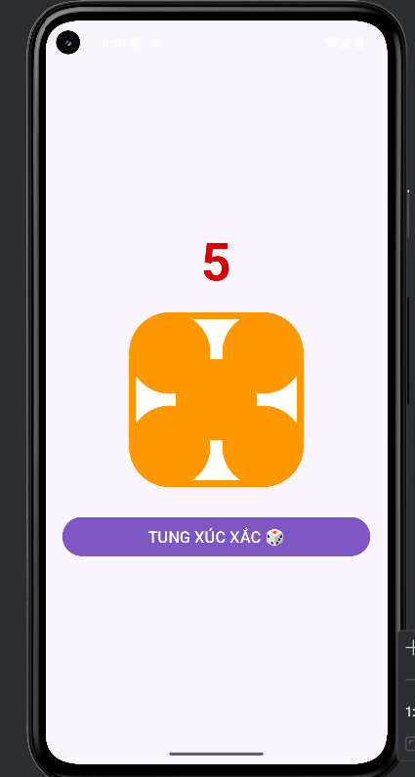

Bài 3:
CallSmsActivity.java
package com.example.firstprogram;
import androidx.appcompat.app.AppCompatActivity;
import androidx.core.app.ActivityCompat;
import androidx.core.content.ContextCompat;
import android.Manifest;
import android.content.Intent;
import android.content.pm.PackageManager;
import android.net.Uri;
import android.os.Bundle;
import android.telephony.PhoneNumberUtils;
import android.text.TextUtils;
import android.widget.Button;
import android.widget.EditText;
import android.widget.TextView;
import android.widget.Toast;
/**
* CallSmsActivity
* - btnDial: mở Dialer (không cần quyền)
* - btnCall: gọi trực tiếp (CALL_PHONE) -> cần runtime permission
* - btnSms: mở ứng dụng nhắn tin (ACTION_SENDTO) -> không cần quyền
*/
public class CallSmsActivity extends AppCompatActivity {
private static final int REQ_CALL_PHONE = 1001;
EditText edtPhone, edtSmsBody;
Button btnDial, btnCall, btnSms;
TextView tvInfo;
@Override
protected void onCreate(Bundle savedInstanceState) {
super.onCreate(savedInstanceState);
setContentView(R.layout.activity_call_sms);
edtPhone = findViewById(R.id.edtPhone);
edtSmsBody = findViewById(R.id.edtSmsBody);
btnDial = findViewById(R.id.btnDial);
btnCall = findViewById(R.id.btnCall);
btnSms = findViewById(R.id.btnSms);
tvInfo = findViewById(R.id.tvInfo);
btnDial.setOnClickListener(v -> openDialer());
btnCall.setOnClickListener(v -> callDirect());
btnSms.setOnClickListener(v -> openSmsApp());
}
private String getPhone() {
return edtPhone.getText().toString().trim();
}
private boolean isPhoneValid(String phone) {
if (TextUtils.isEmpty(phone)) return false;
return PhoneNumberUtils.isGlobalPhoneNumber(phone);
}
// --- Mở bàn phím gọi ---
private void openDialer() {
String phone = getPhone();
if (!isPhoneValid(phone)) {
toastAndInfo("Nhập số điện thoại hợp lệ để mở Dialer.");
return;
}
Uri uri = Uri.parse("tel:" + phone);
Intent intent = new Intent(Intent.ACTION_DIAL, uri);
startActivity(intent);
}
// --- Gọi trực tiếp ---
private void callDirect() {
String phone = getPhone();
if (!isPhoneValid(phone)) {
toastAndInfo("Nhập số điện thoại hợp lệ để gọi.");
return;
}
if (ContextCompat.checkSelfPermission(this, Manifest.permission.CALL_PHONE)
!= PackageManager.PERMISSION_GRANTED) {
ActivityCompat.requestPermissions(this,
new String[]{Manifest.permission.CALL_PHONE}, REQ_CALL_PHONE);
toastAndInfo("Vui lòng cấp quyền CALL_PHONE, sau đó bấm lại 'Call'.");
return;
}
Uri uri = Uri.parse("tel:" + phone);
Intent intent = new Intent(Intent.ACTION_CALL, uri);
startActivity(intent);
}
// --- Mở ứng dụng nhắn tin ---
private void openSmsApp() {
String phone = getPhone();
String body = edtSmsBody.getText().toString();
if (!isPhoneValid(phone)) {
toastAndInfo("Nhập số điện thoại hợp lệ để nhắn tin.");
return;
}
Uri uri = Uri.parse("smsto:" + phone);
Intent intent = new Intent(Intent.ACTION_SENDTO, uri);
if (!TextUtils.isEmpty(body)) {
intent.putExtra("sms_body", body);
}
try {
startActivity(intent);
toastAndInfo("Đã mở ứng dụng nhắn tin. Hãy chọn GỬI để hoàn tất.");
} catch (Exception e) {
toastAndInfo("Không thể mở ứng dụng nhắn tin trên thiết bị này.");
}
}
private void toastAndInfo(String msg) {
Toast.makeText(this, msg, Toast.LENGTH_SHORT).show();
tvInfo.setText(msg);
}
@Override
public void onRequestPermissionsResult(int requestCode, String[] permissions, int[] grantResults) {
super.onRequestPermissionsResult(requestCode, permissions, grantResults);
if (requestCode == REQ_CALL_PHONE) {
if (grantResults.length > 0 && grantResults[0] == PackageManager.PERMISSION_GRANTED) {
toastAndInfo("Quyền CALL_PHONE đã được cấp. Nhấn lại 'Call' để gọi.");
} else {
toastAndInfo("Bạn chưa cấp quyền gọi điện trực tiếp.");
}
}
}
}
activity_call_sms.xml
<?xml version="1.0" encoding="utf-8"?>
<ScrollView xmlns:android="http://schemas.android.com/apk/res/android"
android:layout_width="match_parent"
android:layout_height="match_parent"
android:padding="16dp">
<LinearLayout
android:layout_width="match_parent"
android:layout_height="wrap_content"
android:orientation="vertical">
<TextView
android:layout_width="wrap_content"
android:layout_height="wrap_content"
android:text="Gọi | Nhắn tin"
android:textSize="22sp"
android:textStyle="bold"
android:layout_marginBottom="12dp"/>
<EditText
android:id="@+id/edtPhone"
android:layout_width="match_parent"
android:layout_height="wrap_content"
android:hint="Nhập số điện thoại (ví dụ: 0123456789)"
android:inputType="phone"
android:layout_marginBottom="8dp"/>
<EditText
android:id="@+id/edtSmsBody"
android:layout_width="match_parent"
android:layout_height="wrap_content"
android:hint="Nội dung tin nhắn"
android:inputType="textMultiLine"
android:minLines="3"
android:layout_marginBottom="12dp"/>
<!-- Hàng nút -->
<LinearLayout
android:layout_width="match_parent"
android:layout_height="wrap_content"
android:orientation="horizontal"
android:weightSum="3"
android:layout_marginBottom="12dp">
<Button
android:id="@+id/btnDial"
android:layout_width="0dp"
android:layout_height="wrap_content"
android:layout_weight="1"
android:text="Dial"/>
<Button
android:id="@+id/btnCall"
android:layout_width="0dp"
android:layout_height="wrap_content"
android:layout_weight="1"
android:layout_marginStart="8dp"
android:text="Call"/>
<Button
android:id="@+id/btnSms"
android:layout_width="0dp"
android:layout_height="wrap_content"
android:layout_weight="1"
android:layout_marginStart="8dp"
android:text="SMS"/>
</LinearLayout>
<TextView
android:id="@+id/tvInfo"
android:layout_width="match_parent"
android:layout_height="wrap_content"
android:text=""
android:textColor="#555"
android:padding="6dp"/>
</LinearLayout>
</ScrollView>

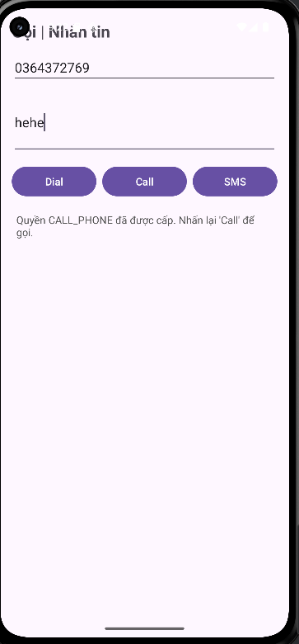
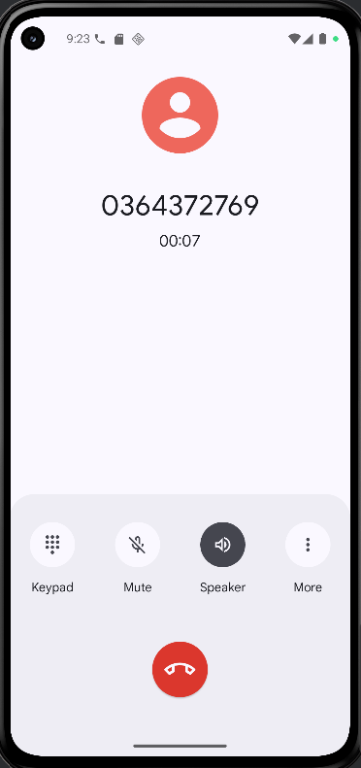
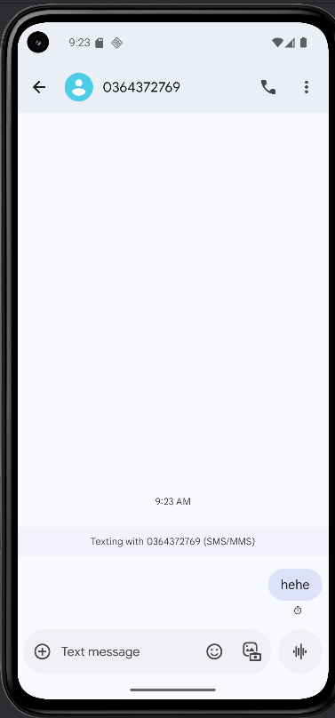
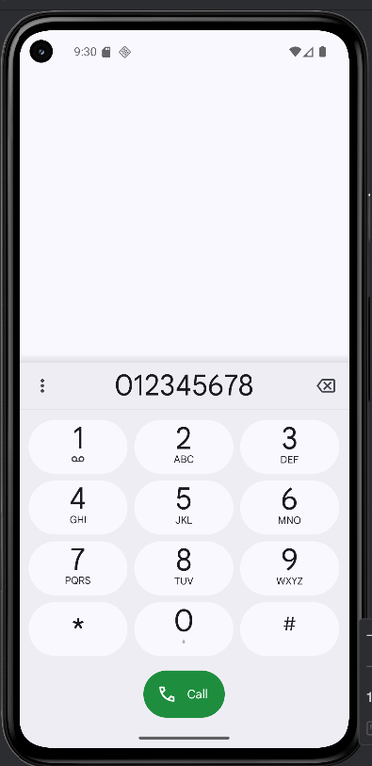

LAB 2
Bài 1+2:
Bai1Activity.java
package com.example.btap8;
import androidx.appcompat.app.AppCompatActivity;
import android.content.Intent;
import android.os.Bundle;
import android.os.Handler;
import android.view.View;
import android.widget.Button;
import android.widget.ImageButton;
import android.widget.ImageView;
import android.widget.LinearLayout;
import android.widget.TextView;
import java.util.Random;
public class Bai1Activity extends AppCompatActivity {
private View loadingView;
private LinearLayout contentLayout, animalInfoLayout;
private ImageView imgAnimal;
private TextView txtTitle, txtAnimalInfo;
private ImageButton btnBack;
private Button btnChange;
private int[] colors = {
0xFFE57373, 0xFF64B5F6, 0xFF81C784,
0xFFFFD54F, 0xFFBA68C8
};
private int[] icons = {
R.drawable.ic_cat,
R.drawable.ic_dog,
R.drawable.ic_lion
};
private String[] names = { "Mèo", "Chó", "Sư tử" };
private String[] infos = {
"Mèo là loài vật nuôi thân thiện, thích nằm ngủ và kêu meo meo.",
"Chó là bạn đồng hành trung thành, thích chạy nhảy và sủa gâu gâu.",
"Sư tử là chúa sơn lâm, biểu tượng của sức mạnh và dũng cảm."
};
private int currentIndex = 0;
private Random random = new Random();
private boolean infoVisible = false;
@Override
protected void onCreate(Bundle savedInstanceState) {
super.onCreate(savedInstanceState);
setContentView(R.layout.activity_bai1);
// Ánh xạ
loadingView = findViewById(R.id.loadingView);
contentLayout = findViewById(R.id.contentLayout);
imgAnimal = findViewById(R.id.imgAnimal);
txtTitle = findViewById(R.id.txtTitle);
btnBack = findViewById(R.id.btnBack);
btnChange = findViewById(R.id.btnChange);
animalInfoLayout = findViewById(R.id.animalInfoLayout);
txtAnimalInfo = findViewById(R.id.txtAnimalInfo);
// Nút quay lại
btnBack.setOnClickListener(v -> {
startActivity(new Intent(Bai1Activity.this, MainActivity.class));
finish();
});
// Delay 2s rồi hiện nội dung
new Handler().postDelayed(() -> {
loadingView.setVisibility(View.GONE);
contentLayout.setVisibility(View.VISIBLE);
updateAnimal();
}, 2000);
// Nút đổi động vật
btnChange.setOnClickListener(v -> {
animalInfoLayout.setVisibility(View.GONE);
infoVisible = false;
updateAnimal();
});
// Khi bấm vào hình con vật
imgAnimal.setOnClickListener(v -> toggleAnimalInfo());
}
private void updateAnimal() {
int colorIndex = random.nextInt(colors.length);
contentLayout.setBackgroundColor(colors[colorIndex]);
currentIndex = (currentIndex + 1) % icons.length;
imgAnimal.setImageResource(icons[currentIndex]);
txtTitle.setText("Animal Sound - " + names[currentIndex]);
}
private void toggleAnimalInfo() {
if (infoVisible) {
animalInfoLayout.setVisibility(View.GONE);
} else {
txtAnimalInfo.setText(infos[currentIndex]);
animalInfoLayout.setVisibility(View.VISIBLE);
}
infoVisible = !infoVisible;
}
}
activity_bai1.xml
<?xml version="1.0" encoding="utf-8"?>
<FrameLayout xmlns:android="http://schemas.android.com/apk/res/android"
xmlns:app="http://schemas.android.com/apk/res-auto"
android:layout_width="match_parent"
android:layout_height="match_parent"
android:background="#FFF9C4"> <!-- Nền vàng nhạt -->
<!-- Thanh tiêu đề màu xanh -->
<View
android:layout_width="match_parent"
android:layout_height="56dp"
android:background="#1976D2" />
<!-- Nút quay lại -->
<ImageButton
android:id="@+id/btnBack"
android:layout_width="40dp"
android:layout_height="40dp"
android:layout_margin="8dp"
android:src="@drawable/ic_back"
android:contentDescription="Quay lại"
android:background="?attr/selectableItemBackgroundBorderless"
android:layout_gravity="start|top"
app:tint="#FFFFFF" />
<!-- Nội dung chính -->
<LinearLayout
android:id="@+id/contentLayout"
android:layout_width="match_parent"
android:layout_height="match_parent"
android:orientation="vertical"
android:gravity="center_horizontal"
android:paddingTop="80dp"
android:visibility="visible">
<!-- Ảnh động vật -->
<ImageView
android:id="@+id/imgAnimal"
android:layout_width="180dp"
android:layout_height="180dp"
android:scaleType="centerInside"
android:src="@drawable/ic_dog"
android:background="@drawable/bg_circle_yellow"
android:padding="20dp"
android:elevation="5dp"
android:clickable="true"
android:focusable="true" />
<!-- Tiêu đề -->
<TextView
android:id="@+id/txtTitle"
android:layout_width="wrap_content"
android:layout_height="wrap_content"
android:layout_marginTop="20dp"
android:text="Animal Sound - Dog"
android:textSize="22sp"
android:textColor="#0D47A1"
android:textStyle="bold"
android:layout_gravity="center_horizontal" />
<!-- Nút đổi động vật -->
<Button
android:id="@+id/btnChange"
android:layout_width="wrap_content"
android:layout_height="wrap_content"
android:text="Đổi động vật"
android:layout_marginTop="30dp"
android:backgroundTint="#388E3C"
android:textColor="#FFFFFF"
android:elevation="4dp" />
<!-- Khung thông tin động vật -->
<LinearLayout
android:id="@+id/animalInfoLayout"
android:layout_width="match_parent"
android:layout_height="wrap_content"
android:orientation="vertical"
android:layout_marginTop="30dp"
android:layout_marginHorizontal="30dp"
android:padding="16dp"
android:background="#FFF59D"
android:elevation="4dp"
android:visibility="gone">
<TextView
android:id="@+id/txtAnimalInfo"
android:layout_width="wrap_content"
android:layout_height="wrap_content"
android:text="Thông tin động vật"
android:textSize="18sp"
android:textColor="#1B5E20"
android:layout_gravity="center" />
</LinearLayout>
</LinearLayout>
<!-- Loading -->
<include
android:id="@+id/loadingView"
layout="@layout/item_loading"
android:visibility="gone" />
</FrameLayout>

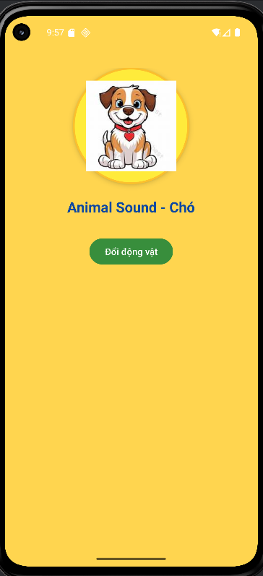
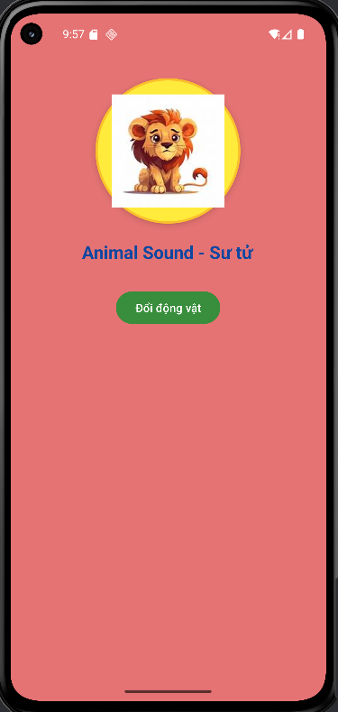
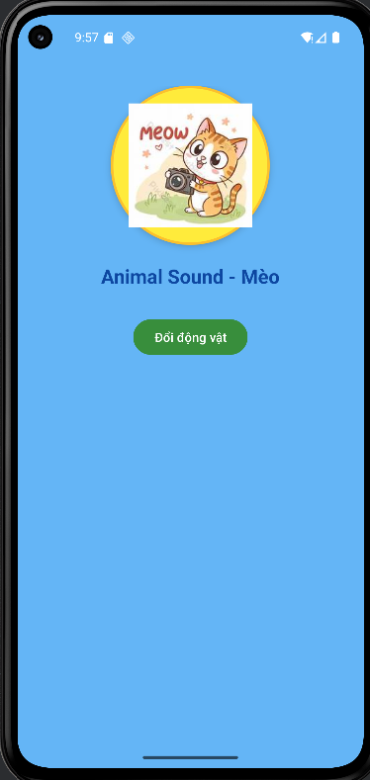
Bài 3:
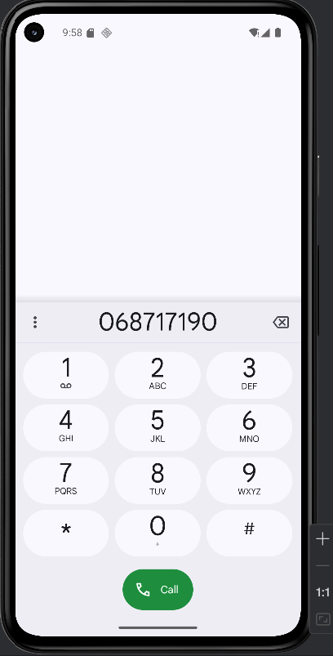
Bài 4:
MainActivity.java
package com.example.btap8;
import androidx.appcompat.app.AppCompatActivity;
import android.content.Intent;
import android.graphics.drawable.AnimationDrawable;
import android.os.Bundle;
import android.widget.Button;
import android.widget.LinearLayout;
public class MainActivity extends AppCompatActivity {
@Override
protected void onCreate(Bundle savedInstanceState) {
super.onCreate(savedInstanceState);
setContentView(R.layout.activity_main);
LinearLayout mainLayout = findViewById(R.id.mainLayout);
AnimationDrawable animationDrawable = (AnimationDrawable) mainLayout.getBackground();
animationDrawable.setEnterFadeDuration(1500);
animationDrawable.setExitFadeDuration(1500);
animationDrawable.start();
Button btnBai1 = findViewById(R.id.btnBai1);
Button btnBai2 = findViewById(R.id.btnBai2);
btnBai1.setOnClickListener(v ->
startActivity(new Intent(MainActivity.this, Bai1Activity.class)));
btnBai2.setOnClickListener(v ->
startActivity(new Intent(MainActivity.this, Bai2Activity.class)));
}
}
activity_main.xml
<?xml version="1.0" encoding="utf-8"?>
<LinearLayout xmlns:android="http://schemas.android.com/apk/res/android"
android:id="@+id/mainLayout"
android:layout_width="match_parent"
android:layout_height="match_parent"
android:gravity="center"
android:orientation="vertical"
android:padding="24dp"
android:background="@drawable/bg_rainbow_animated">
<TextView
android:id="@+id/txtTitle"
android:layout_width="wrap_content"
android:layout_height="wrap_content"
android:text="🌈 Ứng dụng Bài tập 8 🌈"
android:textSize="24sp"
android:textStyle="bold"
android:textColor="#FFFFFF"
android:layout_marginBottom="32dp" />
<Button
android:id="@+id/btnBai1"
android:layout_width="match_parent"
android:layout_height="wrap_content"
android:text="Bài 1: Random Animal"
android:textStyle="bold"
android:backgroundTint="#8E24AA"
android:textColor="#FFFFFF"
android:elevation="5dp"
android:layout_marginBottom="16dp"
android:paddingVertical="12dp" />
<Button
android:id="@+id/btnBai2"
android:layout_width="match_parent"
android:layout_height="wrap_content"
android:text="Bài 2: Loading Overlay"
android:textStyle="bold"
android:backgroundTint="#1976D2"
android:textColor="#FFFFFF"
android:elevation="5dp"
android:paddingVertical="12dp" />
</LinearLayout>

